SOP – Changing the Card type surcharge vs. no surcharge after the transaction
If you accidently select the wrong option for the surcharge in Dash you can fix it without manager approval if you do so within 15 minutes.
In Dash click on Transactions on the left side menu:
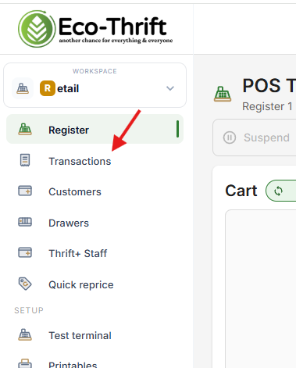
This will take you to the following screen which shows a list of previous transactions
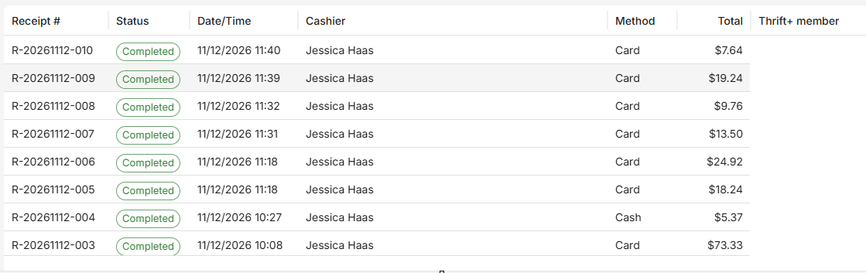
Click on the transaction that needs to be updated
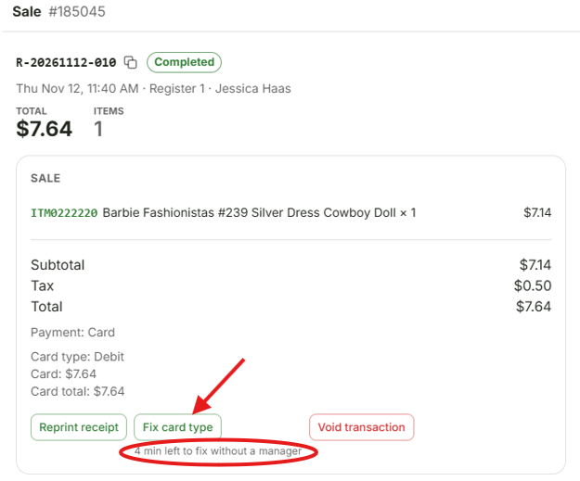
As shown above this transaction has 4 min left to be updated without manager approval. In this screen select “Fix Card Type” which will bring up this screen:
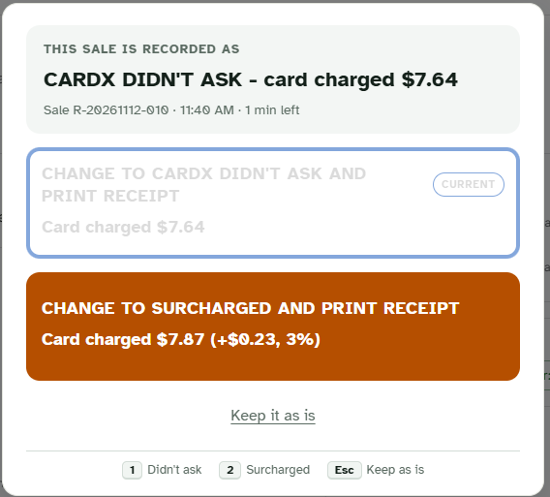

Select the correct card type, this will reprint the accurate receipt which should then be given to the customer.

